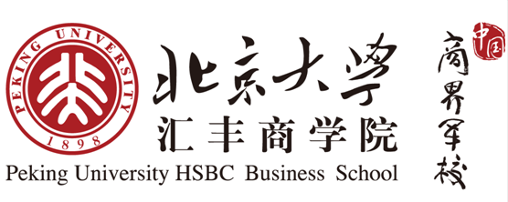
Peking University HSBC Business School
International Student Scholarship Application

In order to be considered for a school-sponsored tuition scholarship, all prospective HSBC Business School students must submit this form along with their supplementary application materials. Students who do not include this form will not be considered for school sponsorship. All scholarships are merit-based and will be reassessed at the end of each academic year to ensure the continued academic excellence of scholarship recipients.

Applicant Information

Name:______________________________________
Nationality: _________________________________  DOB (d/m/y): ______________________________ | Undergraduate: ______________________________  Field of Study: ______________________________

Short Answers |  |  |  |  | Applications without these documents will not be considered,
Please attach a Word document with responses of no more than 300 words each to the following prompts:
- Describe how you have demonstrated leadership ability both in and out of school.
OR
Discuss a special attribute or accomplishment that sets you apart.
- State any special personal or family circumstances affecting your need for financial assistance.
Resume
Please attach a CV or resume highlighting accomplishments which would help the School make its decision.

Student Signature
Name: |  | Date:

Please do not write under the dotted line.

--------------------------------------------------------------------------------------------------------------------------------------------------

Committee Decision
No Scholarship [ ] | Half Tuition Scholarship [ ] | Full Tuition Scholarship [ ]

Dean’s Comments
Agree [ ] | Disagree [ ] | Additional:

